Buckling Analysis in Kratos with IGA and FEM

Objective:
To validate the buckling Analysis in Kratos for Isogeometric and finite element shell element.
- Model Description:
The reference model is taken from Altair Optistruct - link
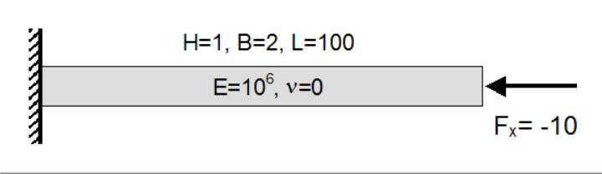

Buckling Eigen Values = [4.112, 16.449, 37.011, 102.81]

- Study:
The following analysis are carried out:
- Hand calculation of the buckling load with Euler Buckling load
- Buckling analysis in Kratos with IGA
- Nonlinear analysis in Kratos with IGA
- Buckling analysis in Kratos with FEA

  - Hand calculation of the buckling load with Euler Buckling load
Euler buckling load = Pi²EI/L²
Where L is the effective length.
Since this is cantilever beam L = 2 * 100 = 200
Then Euler buckling load = 3.14² * 10⁶ * [2*1³/12] / (200²) = 41.081 units

  - Nonlinear analysis in Kratos with IGA

In the nonlinear analysis, the load-displacement curve is plotted. From this plot, the buckling point is inferred from the change in slope (stiffness). Also, an additional load of 0.1 units is applied to weaker bending axis to stimulate second order behaviour.
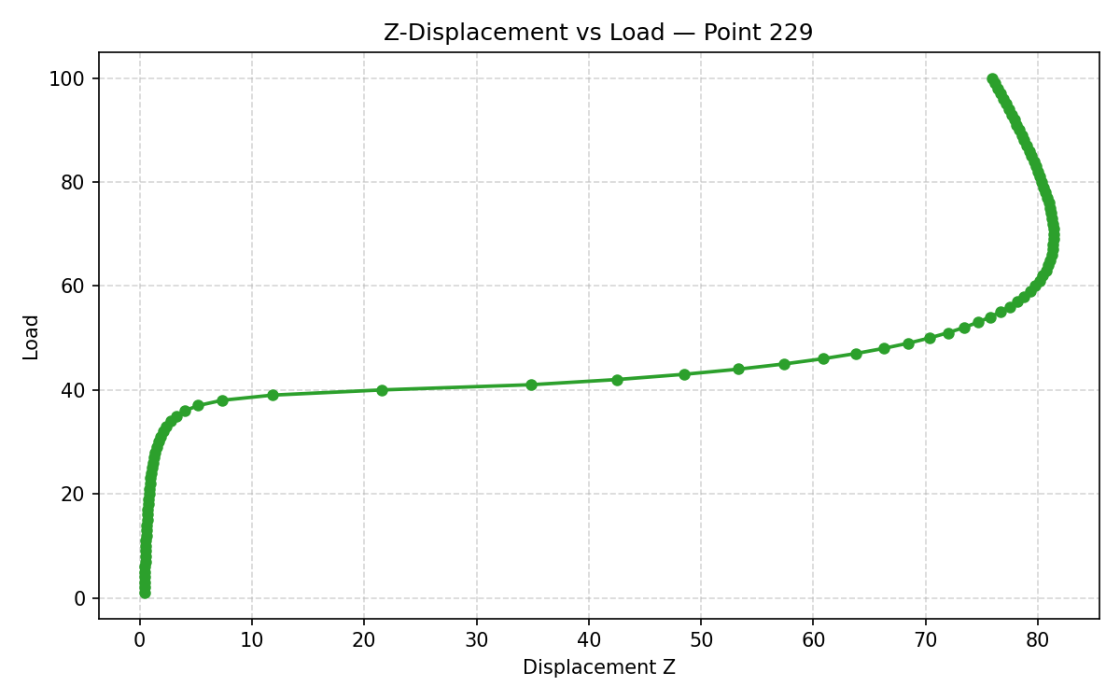
From the figure, it is clear that nonlinear analysis predicts the buckling load – 41.1 Sharp change in stiffness (slope)

  - Buckling analysis in Kratos with FEA
Buckling Eigen Value = 4.1271 units
Since the applied load was 10 units, the buckling load = 4.127 * 10 = 41.271 units

  - Buckling analysis in Kratos with IGA Shell 3P element

Buckling Eigen Values = [ 4.112, 16.617, 37.010, 102.809]

  - Buckling analysis in Kratos with IGA Shell 6p element

Buckling Eigen Values = [ 4.08e-69, 3.19e-49, 5.21e-24, 4.39e-7]

